Code Link:
https://wokwi.com/projects/444175681634130945

Code:
// Week3-Lecture3
// Two Switch Debounce Solution using Timer Interrupt
// Embedded IoT System Fall-2025

// Name: Usama Bin Saeed Reg#: 23-NTU-CS-1094

#include <Arduino.h>

#define LED_PIN1 4 //Pin of first LED
#define BUTTON_PIN1 32 // Button for first LED
#define LED_PIN2 5 //Pin of second LED
#define BUTTON_PIN2 26 // Button for second LED
#define DEBOUNCE_MS 50 // Debounce time
#define DEBOUNCE_US (DEBOUNCE_MS * 1000UL)

hw_timer_t* debounceTimer = nullptr;
volatile bool debounceActive = false; // blocks re-entrant presses while debouncing

// --- One-shot debounce timer ISR ---
// Fires once after DEBOUNCE_MS; confirms press and toggles LED.
void ARDUINO_ISR_ATTR onDebounceTimer() {
// If still pressed after debounce window, treat as a valid press
if (digitalRead(BUTTON_PIN1) == LOW) { // check if button 1 is pressed
digitalWrite(LED_PIN1, !digitalRead(LED_PIN1)); // invert LED state
}else if (digitalRead(BUTTON_PIN2) == LOW){ //check if button 2 is pressed
digitalWrite(LED_PIN2, !digitalRead((LED_PIN2)));
}
debounceActive = false; // allow next press
}

// --- GPIO button ISR ---
// Starts the one-shot debounce timer on a FALLING edge.
void ARDUINO_ISR_ATTR onButtonISR() {
if (!debounceActive) {
debounceActive = true;
// Arm one-shot alarm: autoreload=false, reload_count=0
timerAlarm(debounceTimer, DEBOUNCE_US, false, 0);
}
}

void setup() {
pinMode(LED_PIN1, OUTPUT);
pinMode(LED_PIN2, OUTPUT);
digitalWrite(LED_PIN1, LOW);
digitalWrite(LED_PIN2, LOW);

// Button to GND with internal pull-up; idle HIGH, pressed LOW
pinMode(BUTTON_PIN1, INPUT_PULLUP);
pinMode(BUTTON_PIN2, INPUT_PULLUP);
attachInterrupt(BUTTON_PIN1, onButtonISR, FALLING);
attachInterrupt(BUTTON_PIN2, onButtonISR, FALLING);

// Create a 1 MHz base timer (1 tick = 1 µs) just for debounce

debounceTimer = timerBegin(1000000);
timerAttachInterrupt(debounceTimer, &onDebounceTimer);

// No alarm yet; we arm it on first button edge
}

void loop() {
// Nothing to do. Interrupts handle everything.
}

Output:
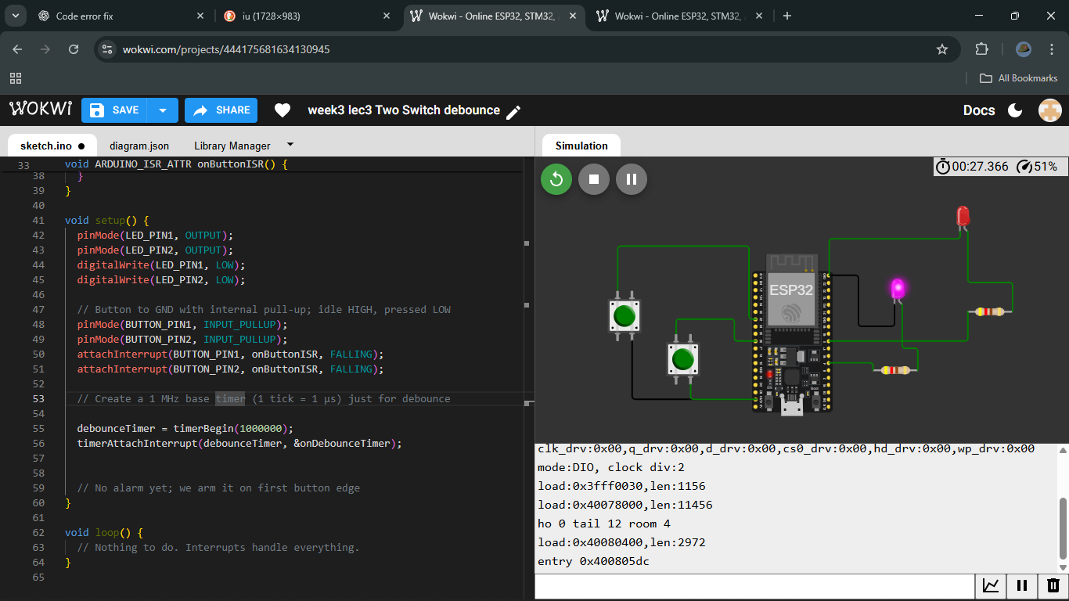
Purple light is on when BUTTON 1 is pressed.
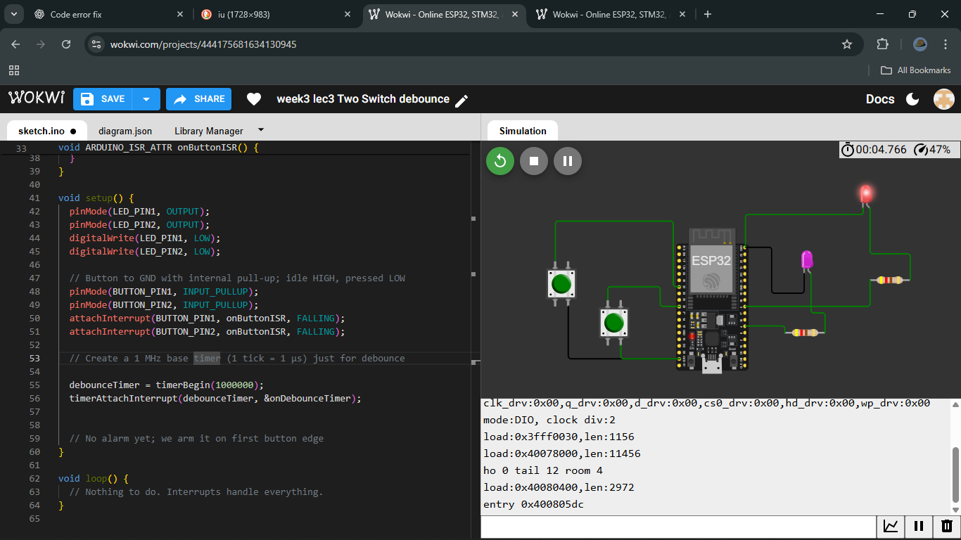
Red light is on when BUTTON 2 is pressed.

